Jenkins Installation:

Jenkins is an open source automation server that has become a crucial component in the likes of Kubernetes and GitOps. Jenkins enables the continuous integration and delivery of software. Jenkins includes a number of plugins to help the automation of building and deploying your applications.

Traditional way of deployment process .

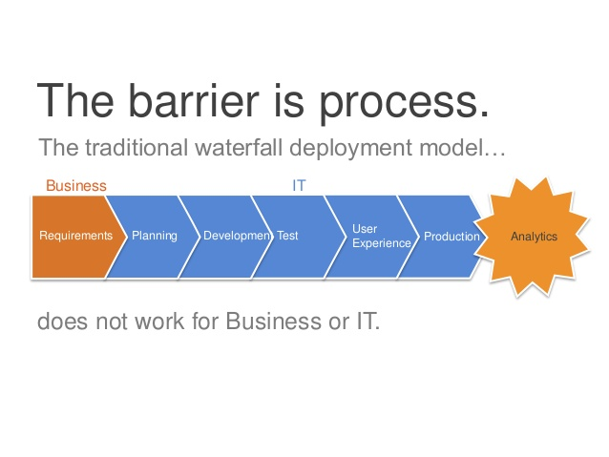

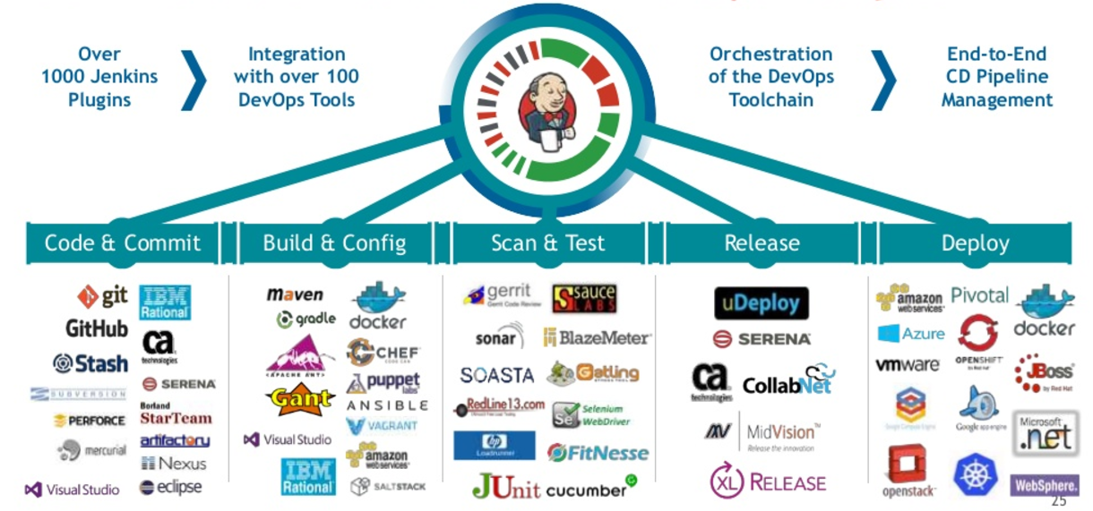

I want to walk you through the process of installing Jenkins on Ubuntu Server 18.04.

**What you'll need to install jenkins**

The only things you'll need are a working instance of Ubuntu 18.04 and a user account with sudo privileges. With those in hand, let's make some automation magic.

Jenkins requires Java to function, Here's how to install a version of Jenkins that will make the installation and usage of Jenkins possible:

1. Open a terminal window on your Ubuntu server.
2. Issue the command *sudo apt install default-jdk-headless*.
3. Allow the installation to complete.

Inorder to verify the java version :

*Java -version*

Successful installation will give the below output

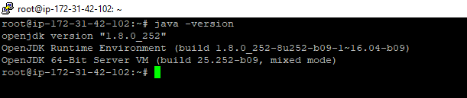

**How to install Jenkins**

Next we install Jenkins. Go back to your terminal window and follow these steps:

1. Download and install the necessary GPG key with the command

 wget -q -O - https://pkg.jenkins.io/debian/jenkins.io.key | sudo apt-key add -

1. Add the necessary repository with the command

sh -c 'echo deb http://pkg.jenkins.io/debian-stable binary/ > /etc/apt/sources.list.d/jenkins.list'

1. Add the universe repository with the command sudo add-apt-repository universe.
2. Update apt with the command sudo apt-get update.
3. Install Jenkins with the command

sudo apt-get install jenkins -y --allow-unauthenticated

**How to install tomcat8 in UBUNTU**

<https://ftp.wayne.edu/apache/tomcat/tomcat-8/v8.5.57/bin/apache-tomcat-8.5.57.tar.gz>

8080 port is the default port of Jenkins and If the port 8080 is using by another server then we need to change the port number is Jenkins file which is located in the below path.

Vim /etc/default/Jenkins

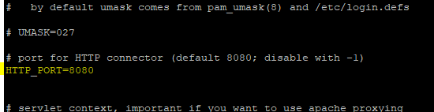

Edit vi /etc/sudoers file and add this line to execute shell command with Jenkins user

jenkins ALL=(ALL) NOPASSWD: ALL